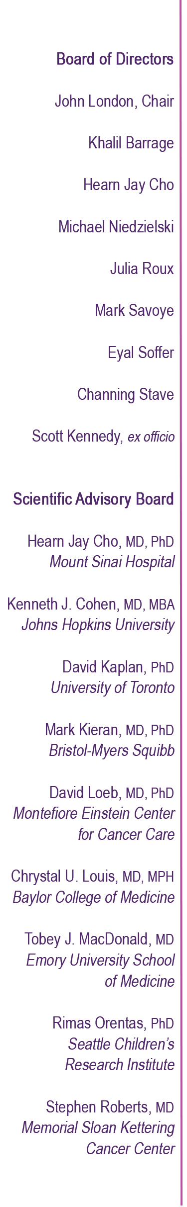

NAME
COMPANY
ADDRESS
CITY, STATE, ZIP
DATE
Dear NAME,

Every two minutes, a child is diagnosed with cancer. One out of five of those kids will not survive their diagnosis, and for the majority of those that do will experience long-term side effects as a result of their treatments. As a benefit committee member of member Solving Kids’ Cancer, I am 100% dedicated to helping improve these statistics.

Solving Kids’ Cancer (SKC) has one mission: to significantly improve survival rates of the deadliest forms of childhood cancers. We focus on identifying and developing new, more effective treatments for kids who have exhausted what is currently available to them. For these children, we are all too often, their last hope.

Each spring, SKC holds a benefit gala to raise significant funds to create new treatments for children who are currently battling aggressive cancers. To be blunt, this night is critical in our ability to further develop therapies that will give the sickest children options they presently do not have. These kids urgently need us all and we truly need you as a funding partner.

This year’s gala will be held in New York City on Thursday, May 16th at the Mandarin Oriental, located in Columbus Circle. .

I hope you will join us at our signature event and consider this early opportunity to be a leading partner with Solving Kids’ Cancer by committing to an individual or corporate table sponsorship. The enclosed form details the levels of participation. Please fill out the form, return it to our benefit office and you’ll be a vital part of an uplifting evening, and even more importantly, you’ll make an impactful, life-changing difference in the lives of sick children and their families
Many thanks and I hope to greet you on May 16!

NAME
EMAIL ADDRESS

